**RECIPE MANAGEMENT SYSTEM**

Name: Ann Mariya Benny

Roll No: 16

Course Name : Programming in C

Date:17/07/24

***INTRODUCTION:***

This project aims to develop a simple recipe management system using the C programming language. The system allows users to add recipes, view all recipes, search recipes by cuisine, and save recipes to a file.

***Problem Statement***

Managing recipes can be a tedious task, especially when dealing with multiple recipes. A system is needed to organize and search recipes efficiently.

***Objective***

The objective of this project is to design and develop a Recipe Management System that allows users to add, view, search, and save recipes.

***System Requirements:***

- Hardware Requirements: Any computer with a C compiler installed

- Software Requirements: C compiler (e.g., GCC)

***Design and Development:***

**Description of the Program Logic**

The program uses a Recipe structure to store information about each recipe, including its name, ingredients, number of ingredients, cooking instructions, and cuisine type. The program provides a menu-driven interface for users to interact with the system.

***Flowchart or Pseudocode:***

**Pseudocode:**

1. Initialize an array to store recipes and a variable to track the number of recipes.
2. Display the menu options to the user.
3. Based on the user's choice, perform the corresponding action:
   * Add a new recipe.
   * View all recipes.
   * Search recipes by cuisine type.
   * Save recipes to a file.
   * Exit the program.
4. Implement functions for each action:
   * **Add Recipe:** Collect recipe details from the user and store them in the array.
   * **View Recipes:** Display all stored recipes.
   * **Search by Cuisine:** Search and display recipes matching the specified cuisine.
   * **Save to File:** Save all recipes to a text file.
5. Repeat the process until the user chooses to exit.

***Testing and Results:***

**Test Cases**

1. **Test Case 1:** Adding a Recipe
   * **Input 1:**
   * Recipe Name: Sharja shake
   * Cuisine: Indian
   * Number of Ingredients: 5
   * Ingredients: Milk ,banana ,sugar ,essence ,boost
   * Instructions: Take mixer ,add sliced banana, frozen milk, sugar and essence in it .Blend it all together until it becomes in the form of thick sweet cold mixture. For further decoration use some boost.
   * **Expected Output:** Recipe added successfully!
   * **Input 2:**
   * Recipe Name: tea
   * Cuisine: Indian
   * Number of Ingredients: 4
   * Ingredients: tea leaves , milk ,sugar ,water
   * Instructions: Boil some water and milk. After both gets heated , add some tea leaves and sugar.
2. **Test Case 2:** Viewing All Recipes
   * **Input:** View all recipes command
   * **Expected Output:** Display the list of all stored recipes.
3. **Test Case 3:** Searching Recipes by Cuisine
   * **Input:** Cuisine: Indian
   * **Expected Output:** Display all recipes with the Indian cuisine.
4. **Test Case 4:** Saving Recipes to File
   * **Input:** Save recipes command
   * **Expected Output:** Recipes saved to file successfully.
5. **Output Screenshots or Results**

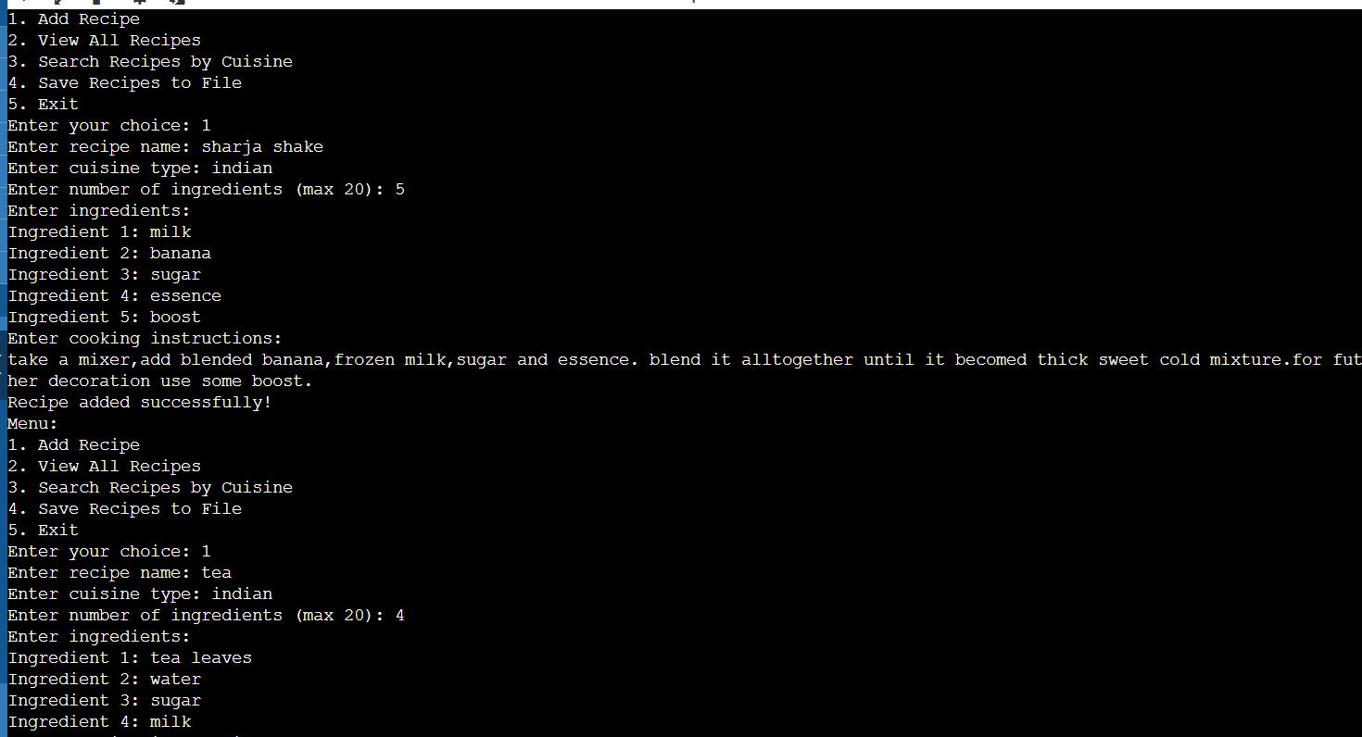

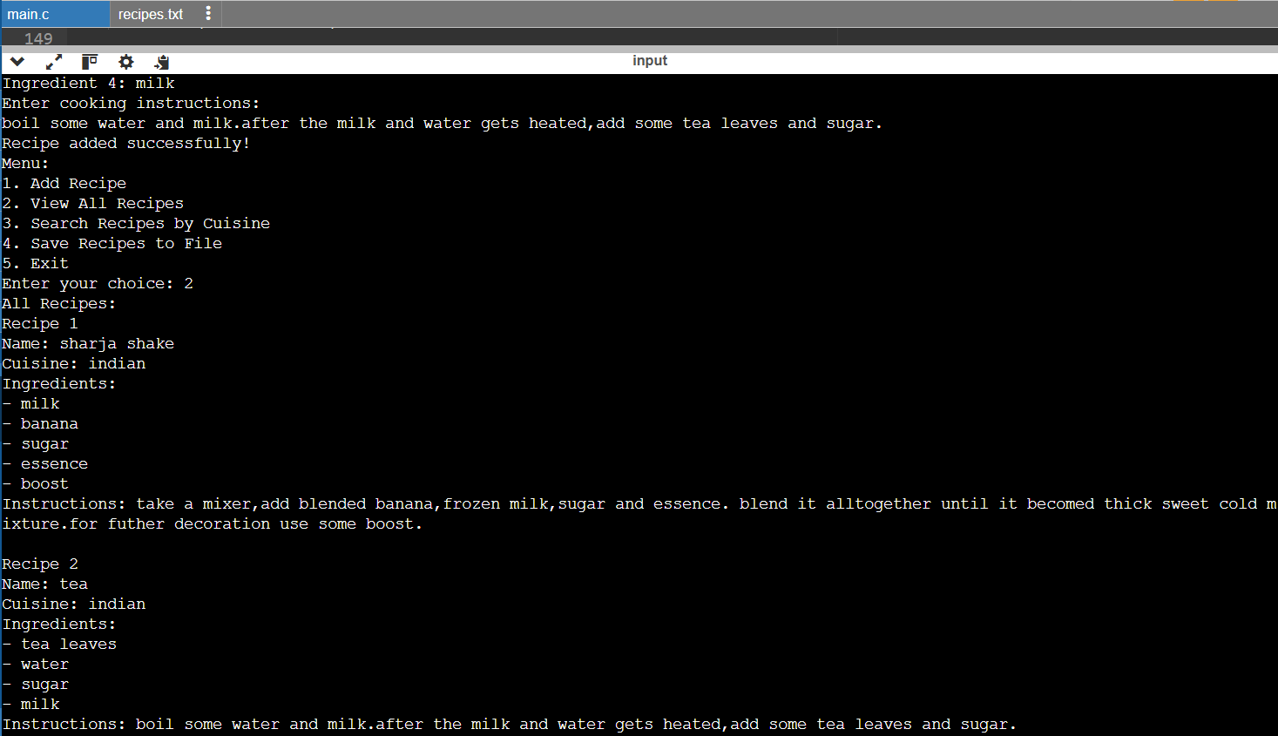

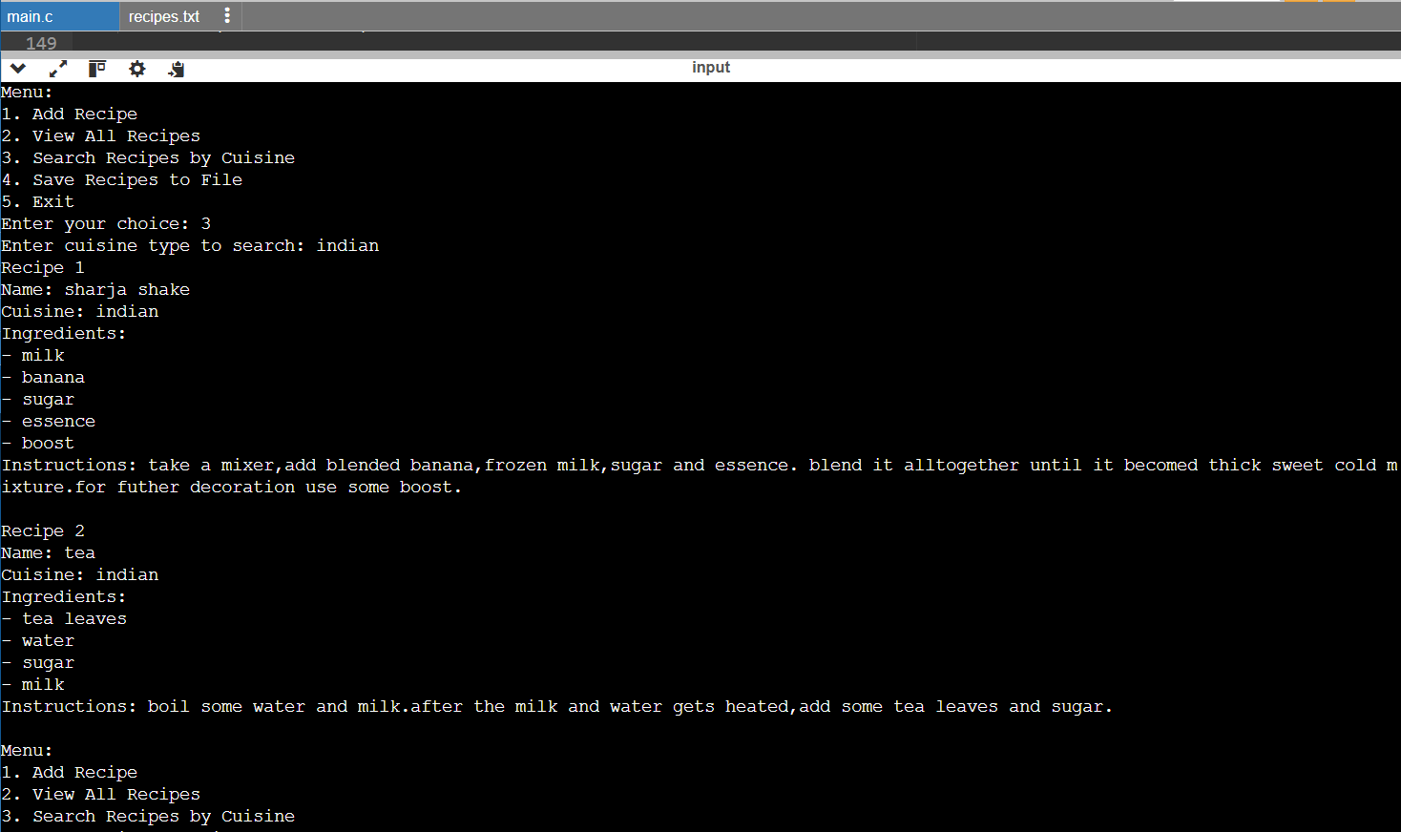

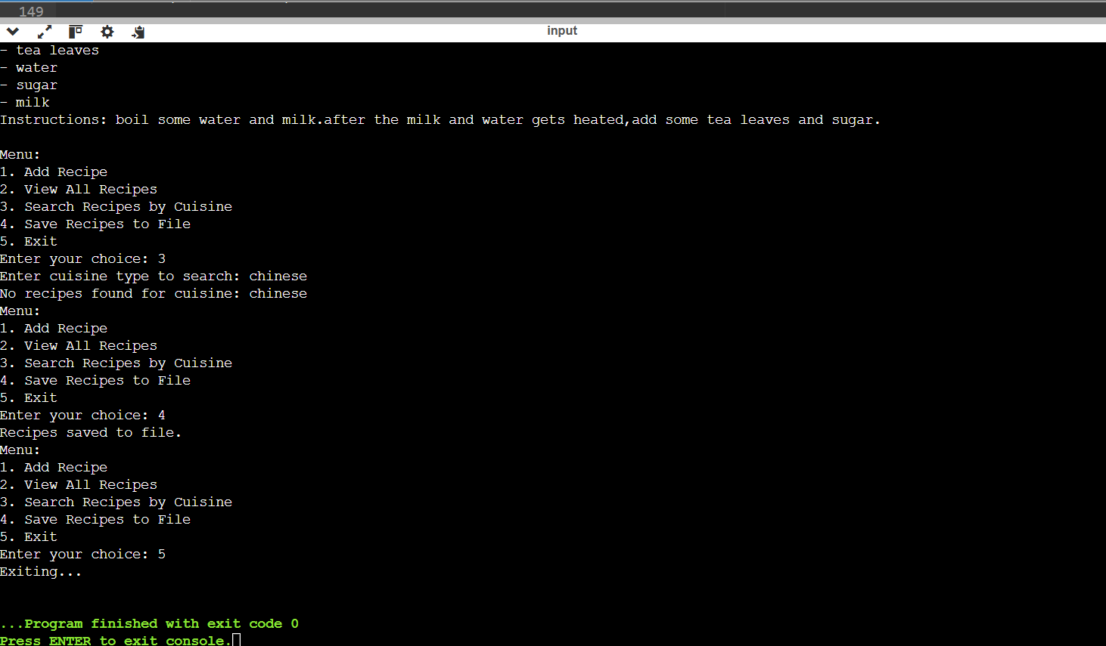

### Conclusion

**Summary of the Project**

This project successfully developed a recipe management system in C, allowing users to add, view, search, and save recipes. The project met its objectives and demonstrated the practical application of structures, arrays, and file I/O in C.

**Future Enhancements**

Future versions of this project could include:

1. Enhanced user input validation.
2. Editing existing recipes.
3. Deleting recipes.
4. Improved file handling for better data persistence.

**References**

* [Any references or textbooks used for C programming]
* [Online tutorials or documentation]

### Appendices

#### Code Listing

